## Your Main Tasks:

### Time Measurement:

- **Measure the execution time for each command to assess their

performance.

``` bash

I will use $time {command}

```

### System Interaction Identification:

- **Identify which system stack (e.g., file system, network) each command

interacts with during execution.

``` bash

I will use $ strace -c -e trace={stack} {command}

```

### Syscall Time Breakdown:

- **Break down the total execution time of each command into time per

system call to understand their resource consumption.

``` bash

I will use $ strace -c {command}

```

### Performance Evaluation:

- **Analyze the results to determine which command performs better than the

other based on execution time, system interaction, and syscall breakdown.

# ls vs. find

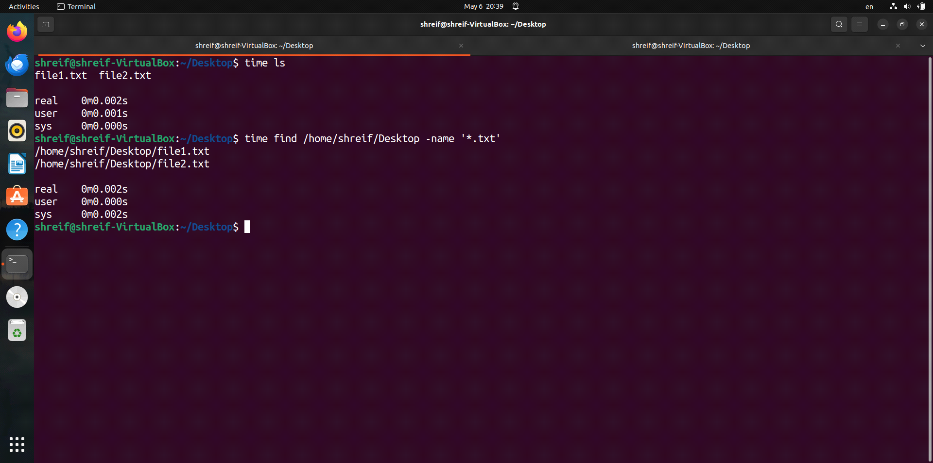

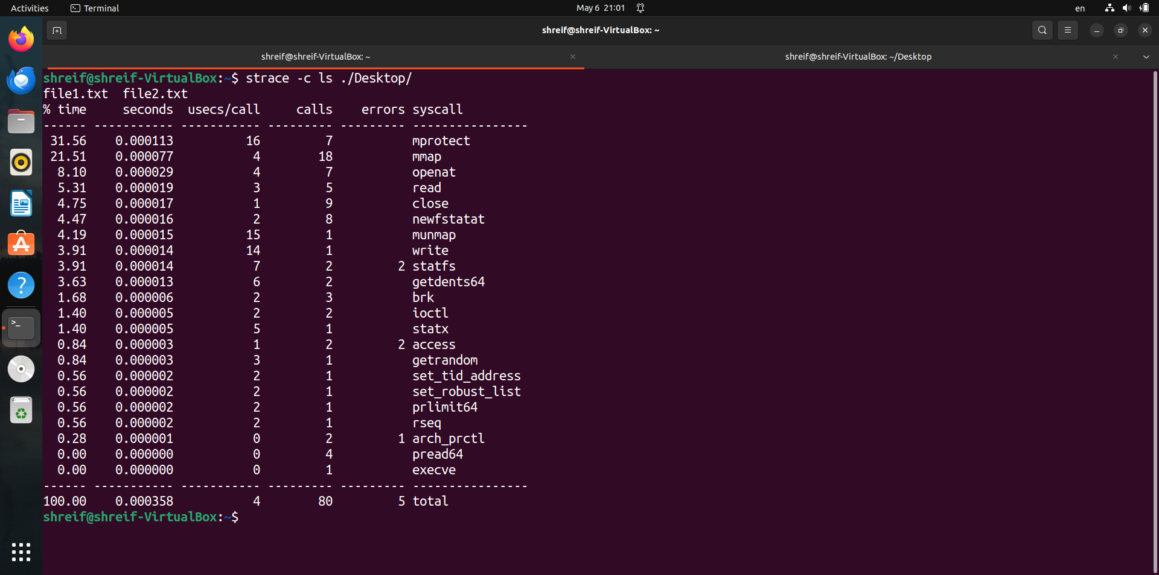

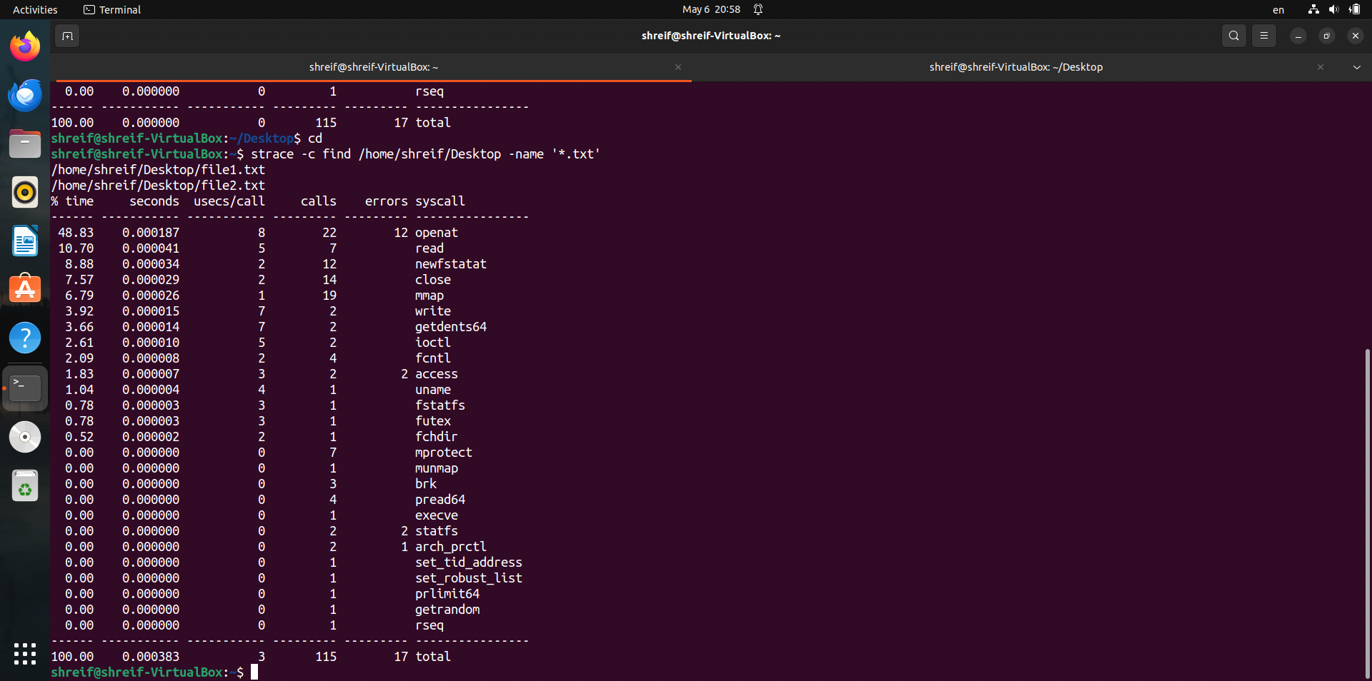

# cp vs. rsync

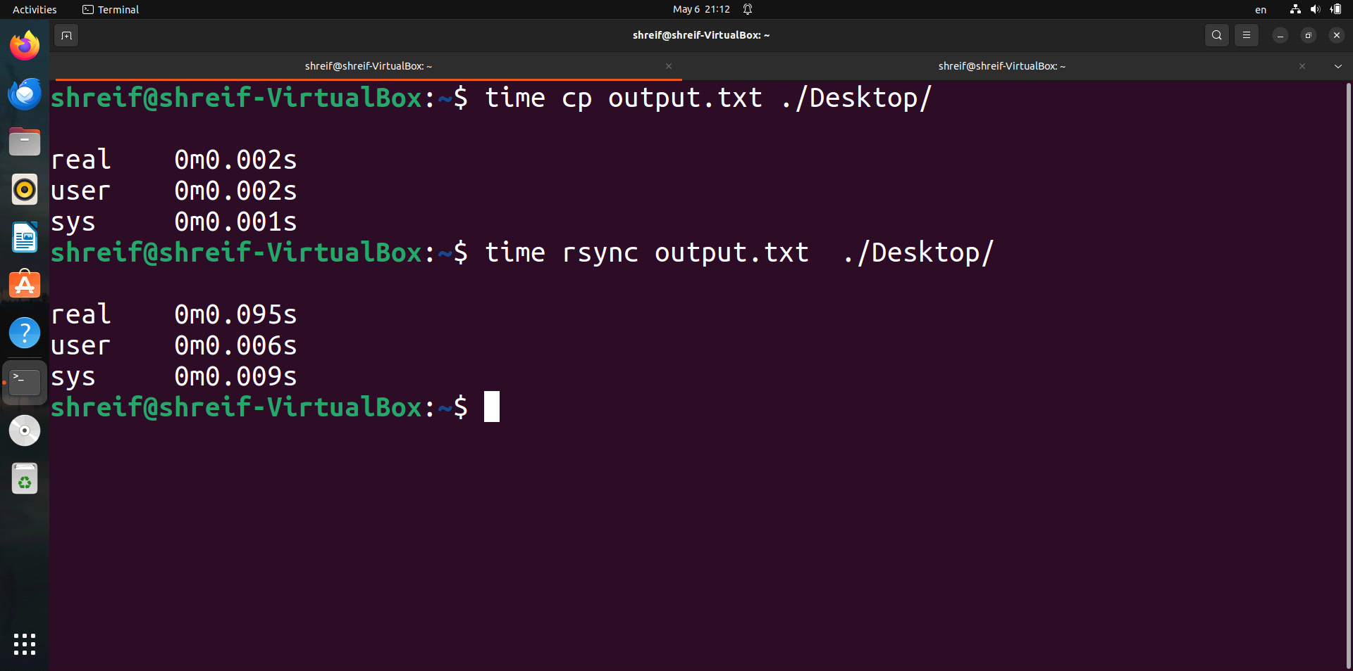

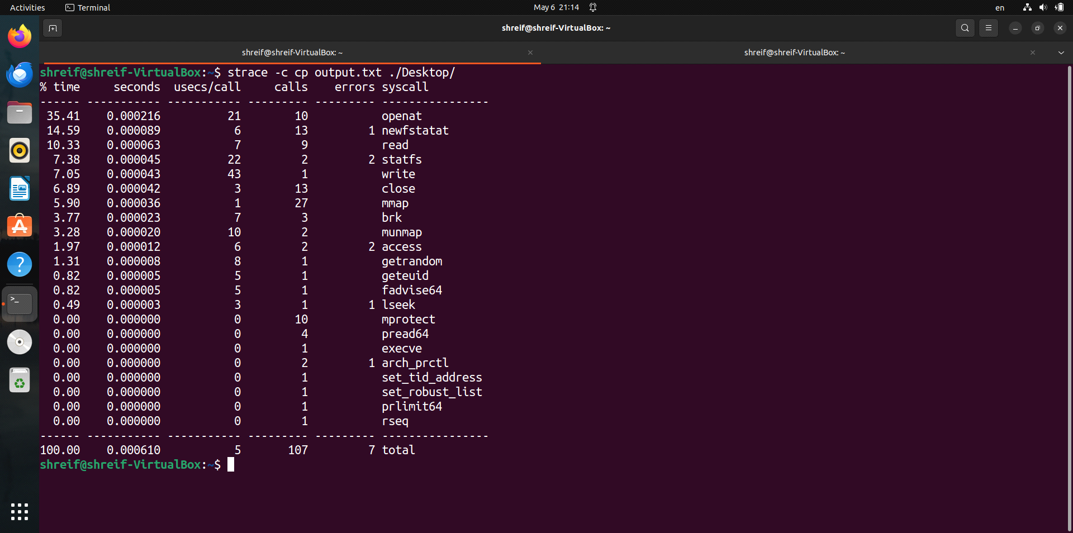

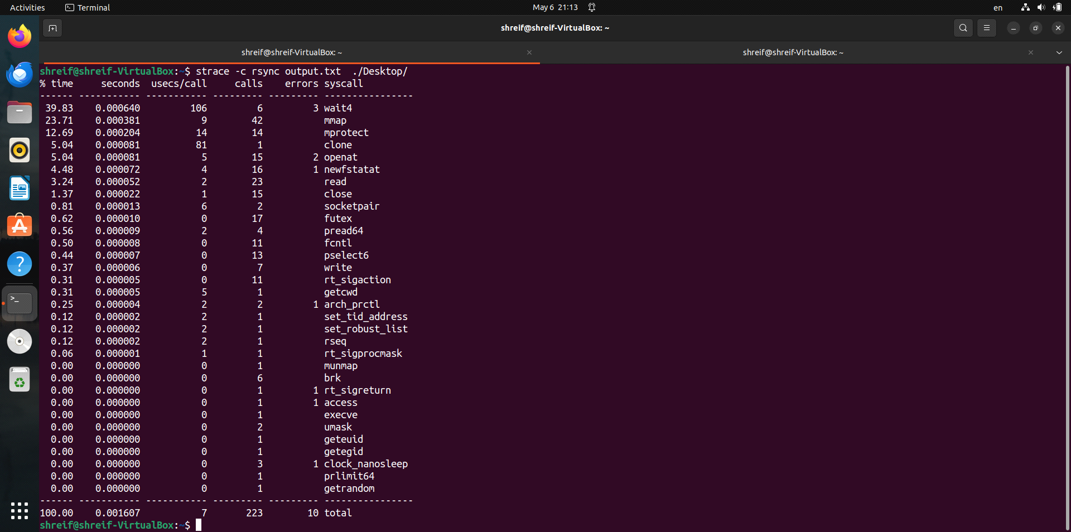

# diff vs. cmp

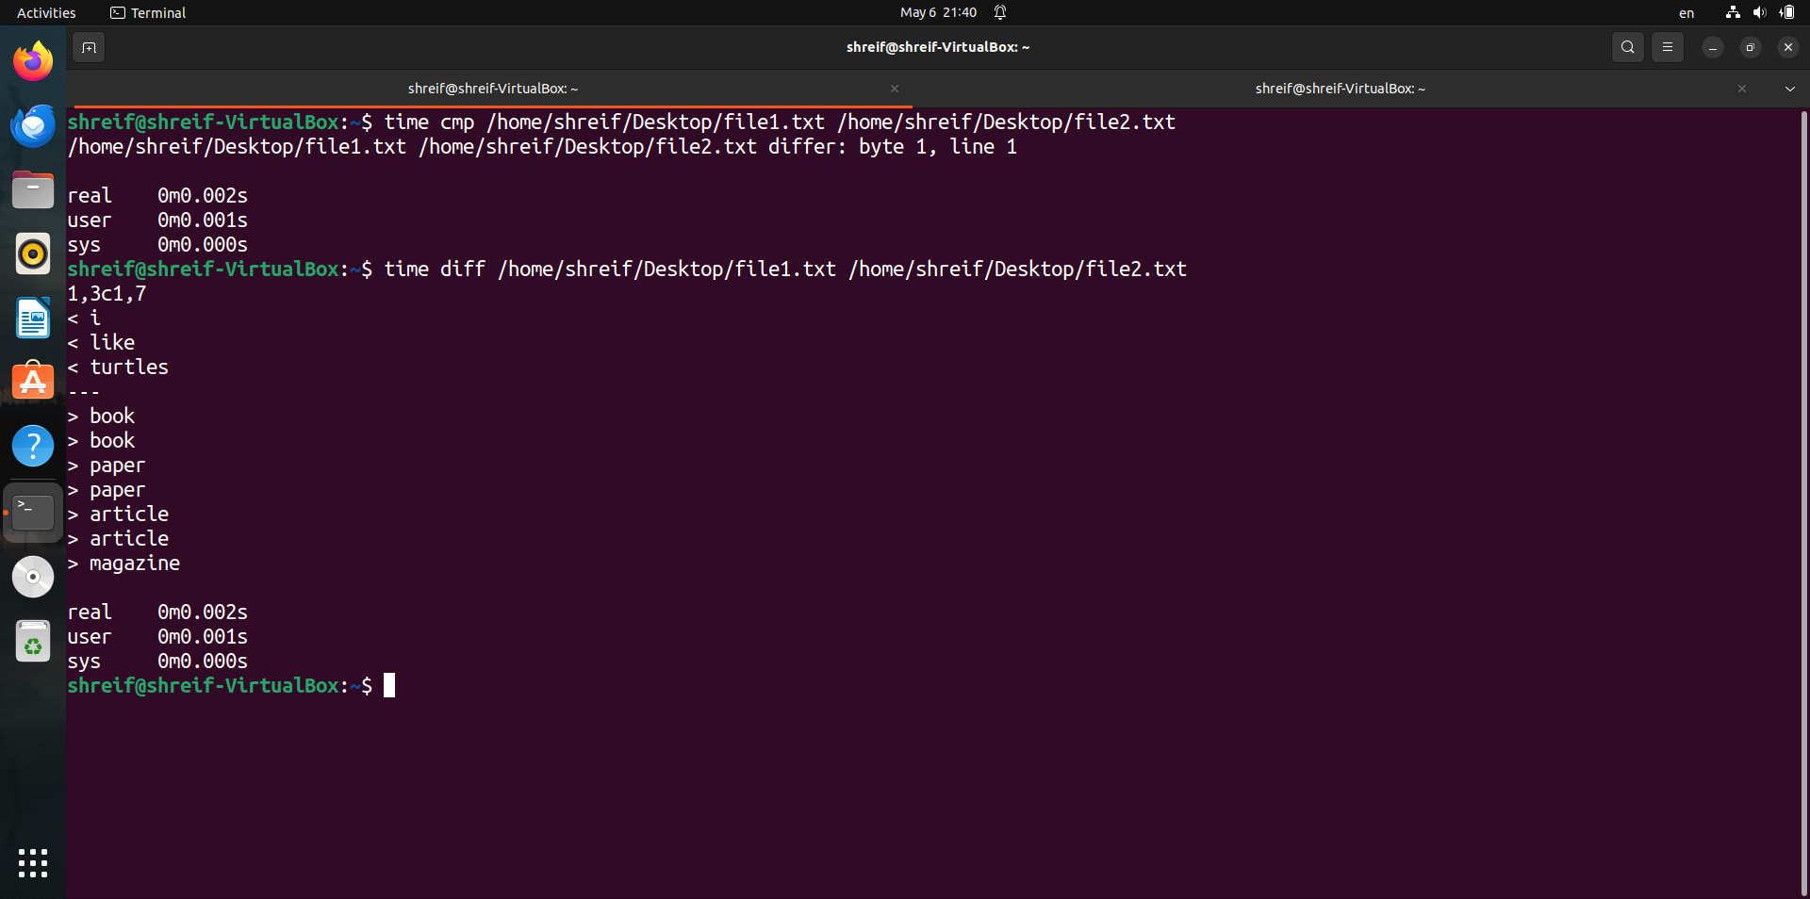

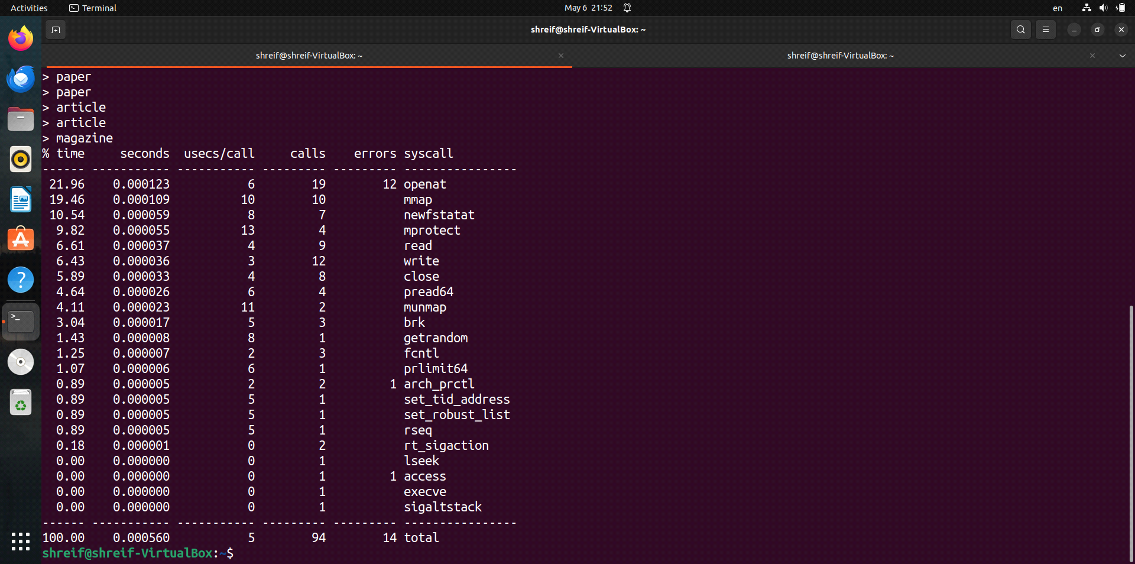

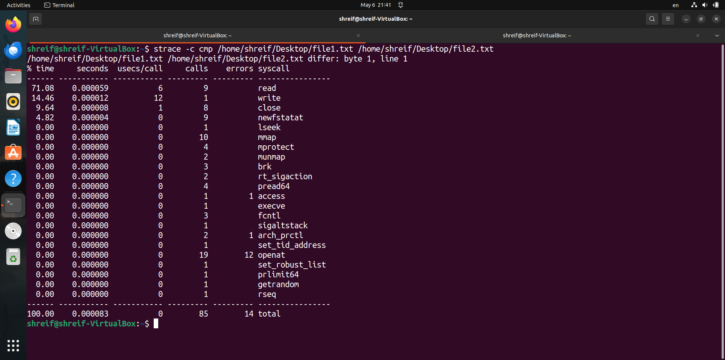

# sort vs. uniq

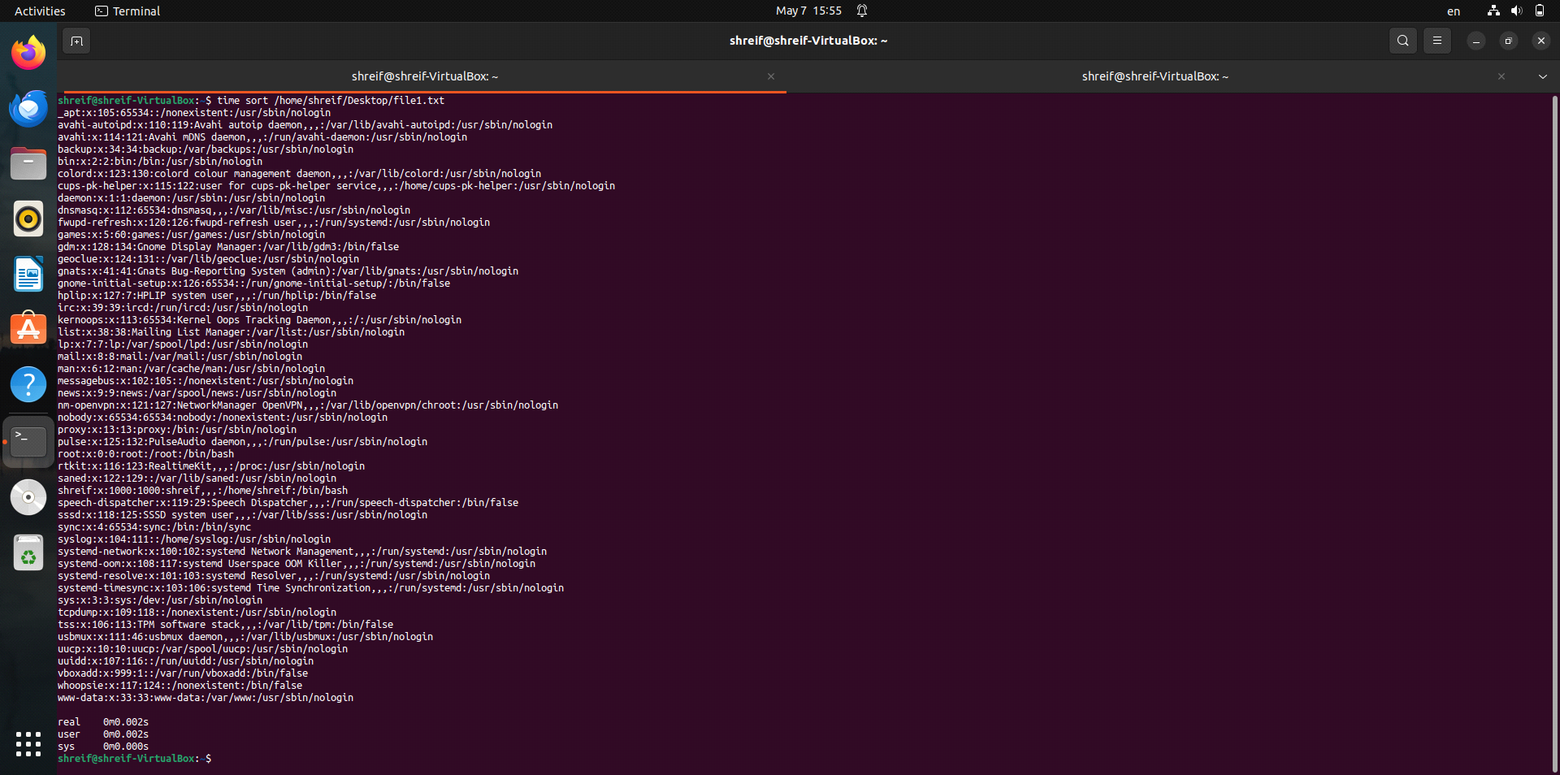

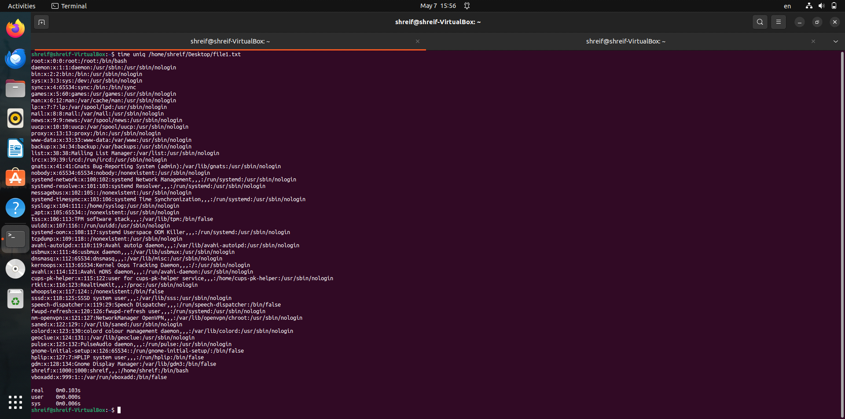

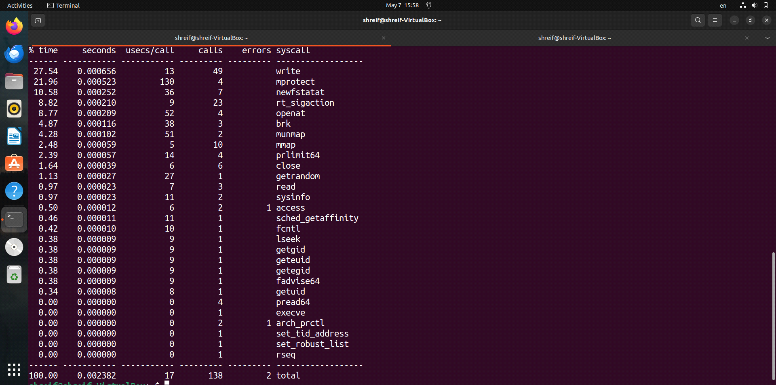

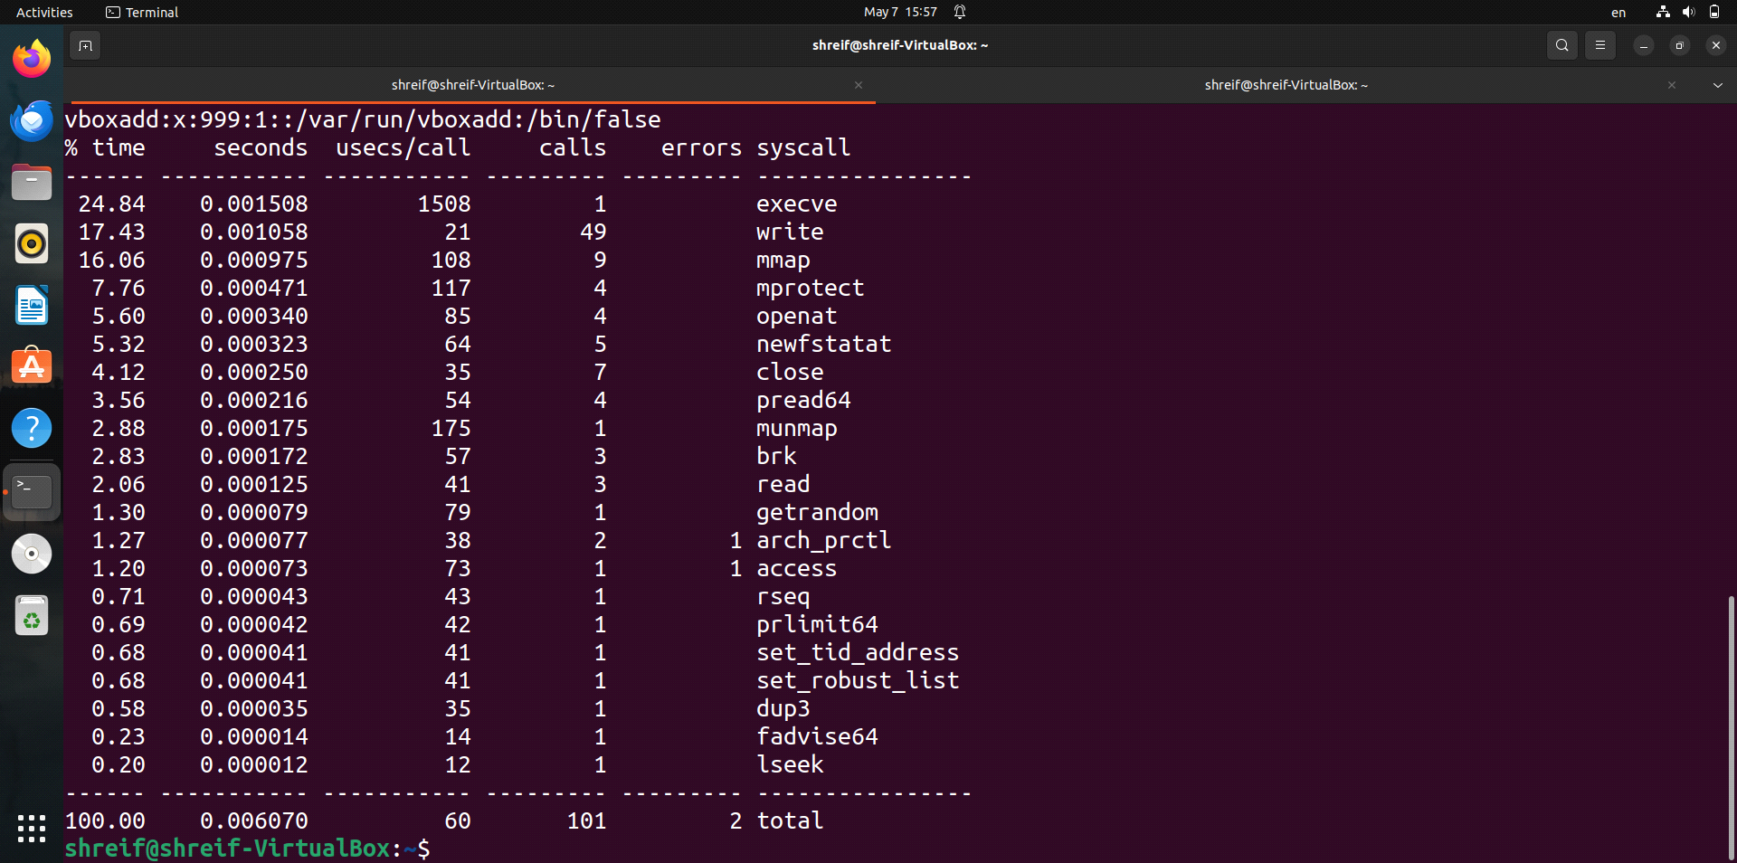

# grep vs. sed

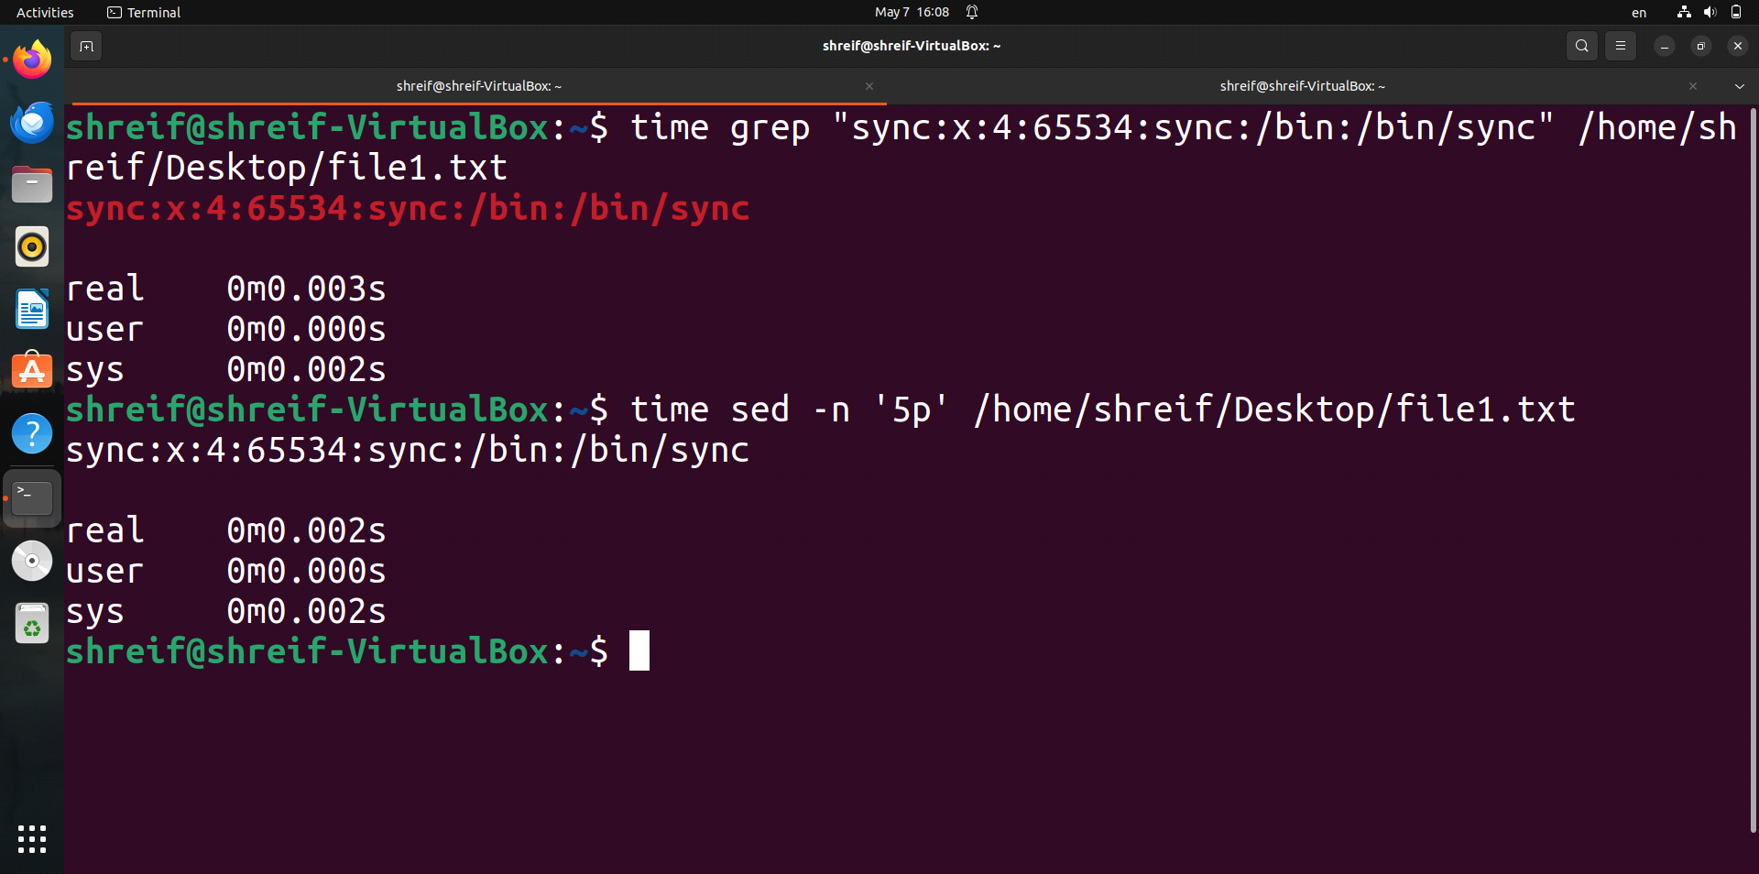

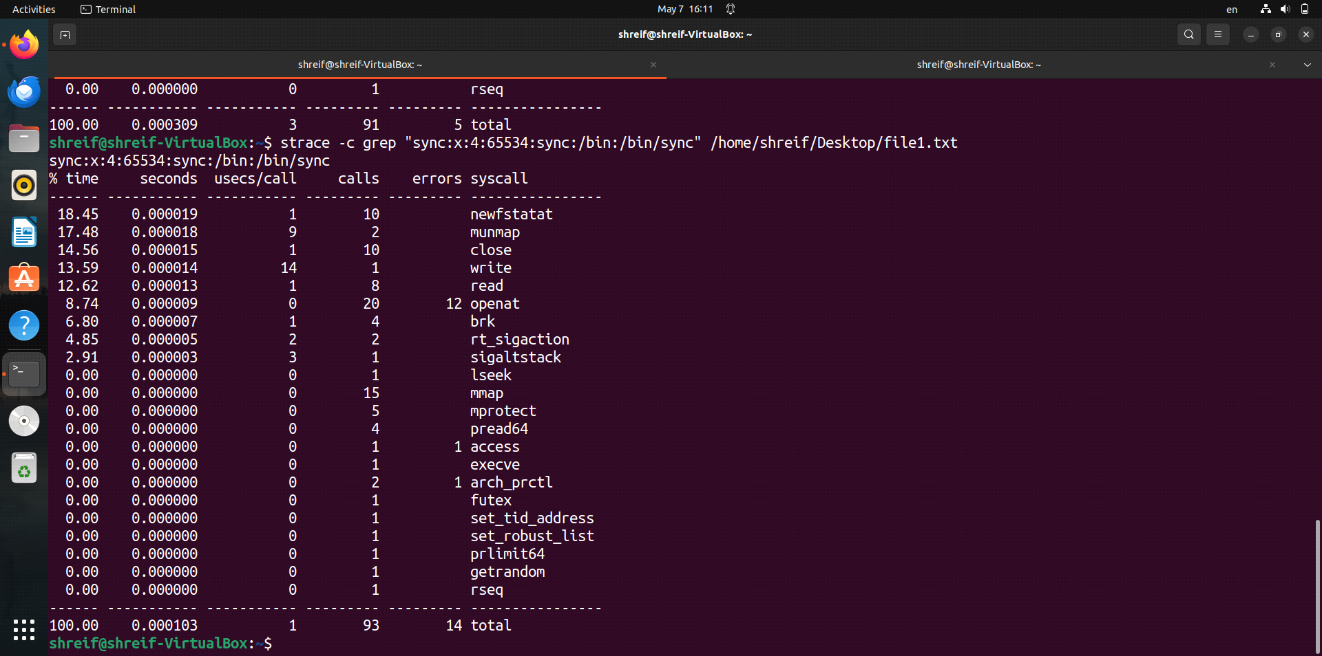

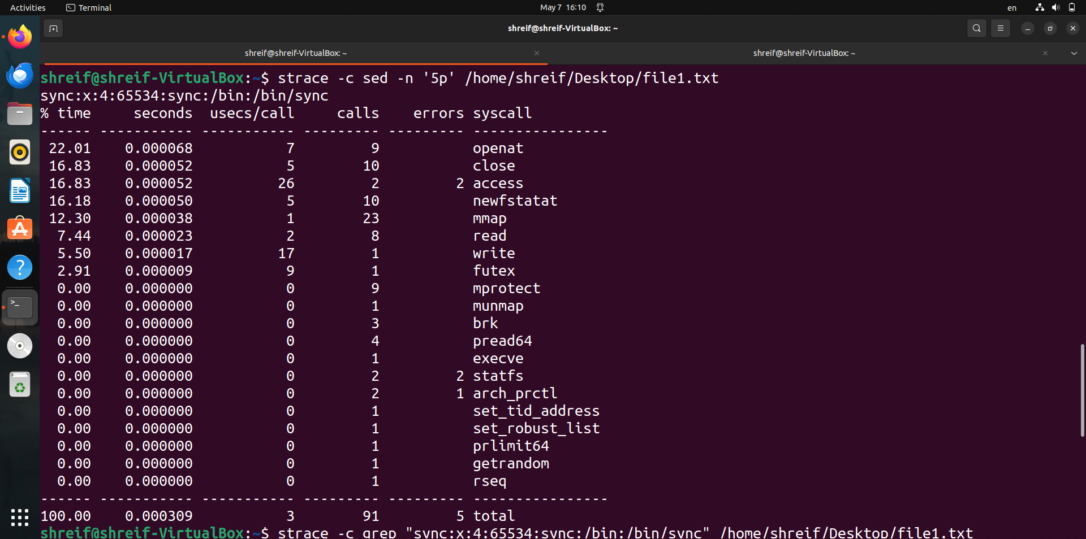

| Command | Time | No.of Stacks | Time break down | Performance |

| ------------- | --------- | ------------ | --------------- | ----------- |

| ls vs. find | ls | same number | ls | ls |

| cp vs. rsync | cp | rsync | cp | cp |

| diff vs. cmp | same time | same number | cmp | cmp |

| sort vs. uniq | sort | same number | sort | sort |

| grep vs. sed | sed | same number | grep | grep |

| Filesystem Stack | Network Stack | Memory management Stack | Process Stack |

| ---------------- | ------------- | ----------------------- | ------------- |

| ls, find | rsync | ls, find | ls, find |

| cp, rsync | ------ | cp, rsync | cp, rsync |

| diff, cmp | ------ | diff, cmp | diff, cmp |

| sort, uniq | ------ | sort, uniq | sort, uniq |

| grep, sed | ------ | grep, sed | grep, sed |